Leaf Anatomy
Modified Leaves

Leaf Anatomy
Introduction
In studying the characteristics of stems and roots in previous laboratories, you have seen structures specialized for physical support and for absorption and conduction of water and minerals. This lab deals with the third vegetative plant organ typical of land plants: the leaf. Leaves have evolved as plant organs that are (1) obviously adapted for light interception and (2) subtly adapted for carbon dioxide uptake from the atmosphere for photosynthesis. Because of their large surface area and because they have pores for gas exchange, leaves are very vulnerable to water loss. This vulnerability results in a final adaptation found in all terrestrial vascular plant leaves: (3) features that prevent excess water loss but at the same time reduce CO2 uptake.
What is contradictory about a leaf preventing water loss? If the leaf were completely water tight, it would also be completely air tight, and the carbon dioxide supply would be cut off. That would be fatal in the long run, for a plant would starve to death! An ideal leaf would allow carbon dioxide to enter without allowing any water to escape. The best scheme that evolution has produced, a system of controllable pores, stomates, falls far short of that ideal.
Stomate control of water loss will be dealt with extensively in a later lab, but even now it is valuable to know a little about stomate response. Stomates tend to open when conditions are good for photosynthesis. They tend to close when drying conditions are extreme.
There is a tradeoff between photosynthesis and drought avoidance. If stomates are open, more food can be made but more water is lost from the plant. An average plant is likely to take up at least 20 times as much water as it needs to supply its cells, losing the excess to the atmosphere without any major benefit. Possible minor benefits include cooling and increased mineral uptake with the water.
The surface layers of the leaf (epidermis), where the stomates occur, are transparent, so opening and closing of the stomates has little effect on light absorption.
Exercises

Gross Leaf Anatomy and Plant Identification
On an individual plant, leaves respond in their size and form (see Exercise D) to prevailing environmental conditions. That somewhat limits their value for identifying a species. Flowers, in contrast, tend to very consistent in their size and structure. Guides to plant identification typically focus most on flower parts. Still, leaves are likely to be present on a plant throughout the growing season, while flowers may be transitory, the fruits that grow from them quickly disseminated or eaten by animals, or even completely absent if the plant is immature or growing in an unfavorable site. The following material summarizes leaf characteristics that are useful in plant identification.

Basic Leaf Structure.
Most plant leaves consist of a thin, flattened light interception surface, the blade or lamina; and an attaching stalk, the petiole. In angiosperms, as shown in a previous lab, there is an axillary bud where the leaf joins the stem. There may also be a pair of stipules present at the point of leaf attachment. In some species, stipules are blade-like; in others, papery or even spine-like. Most leaves also show surface evidence of their internal plumbing as a distinctive vein pattern. Dicotyledon leaves typically have a number of principal lateral veins diverging from a midrib. Monocotyledon leaves usually have a number of main veins running parallel to the midrib, which itself may or may not be prominent. Label the blade, petiole, stipules, midrib and side veins in Figure 7-1. Does this leaf have a dicot or a monocot vein pattern?
In many species, the blade is further subdivided into leaflets (see details below), which may themselves look very much like individual leaves. Leaflets, however, have neither axillary buds nor stipules. Both leaves and leaflets may be sessile (no petiole).
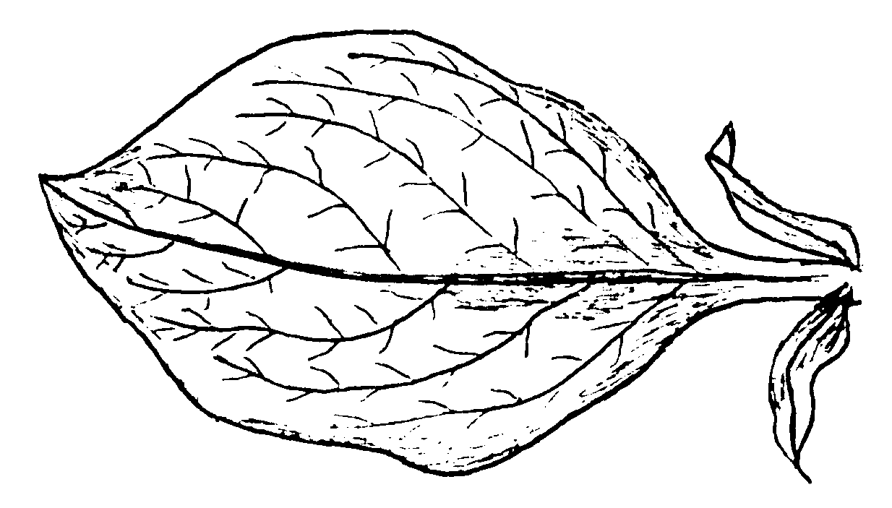
Figure 7-1. Dicot Leaf.

Graminoid (Grass-Like) Leaves
Grasses and many other monocots have leaves in which the lower portion is a sheath that encircles the stem. The upper portion is likely to be a conventional blade, albeit a long and narrow one. Leaf sheaths often overlap one another with the result that several concentric sheaths surround the lower part of the stem. Study the labels in Figure 7-2 and compare the illustration with the actual leaf structure of grasses on display in the lab.
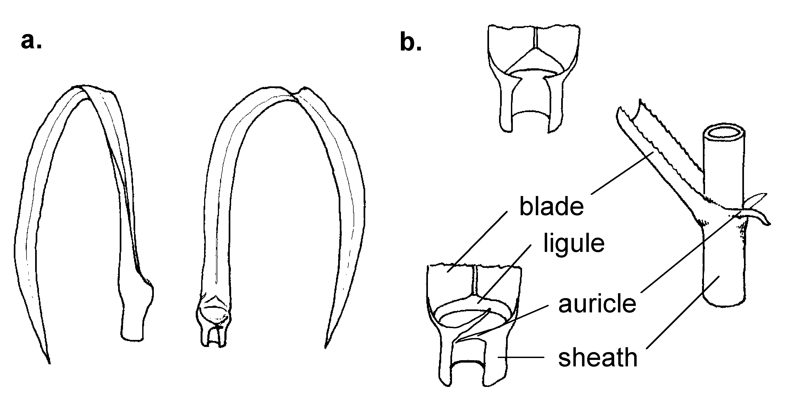
Figure 7-2. Grass Leaves. a. General. b. Detail of Intersection with Stem.

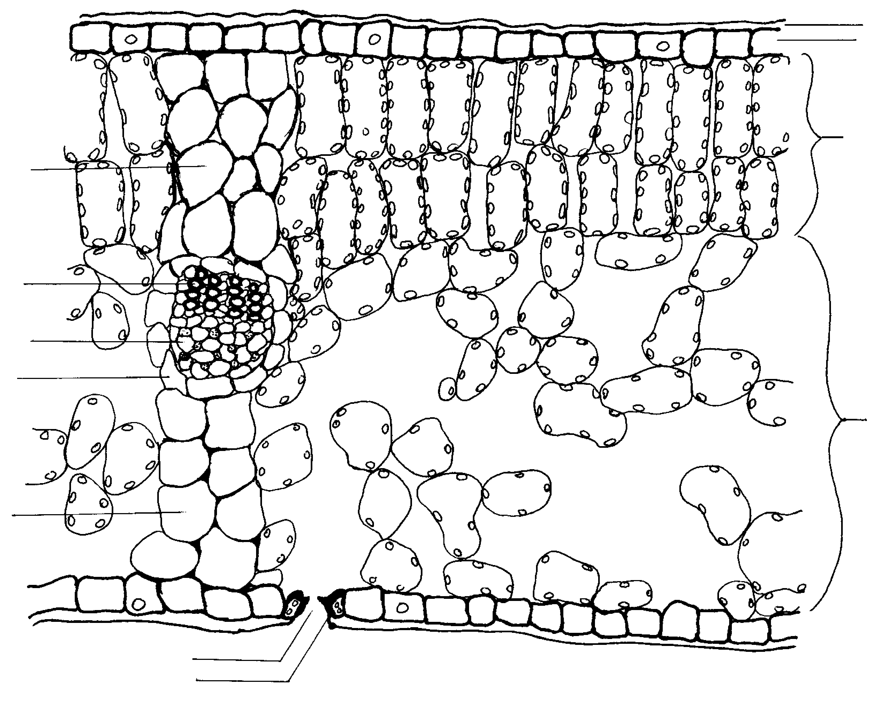
Figure 7-3. Lilac (Syringa) Leaf Cross-Section.
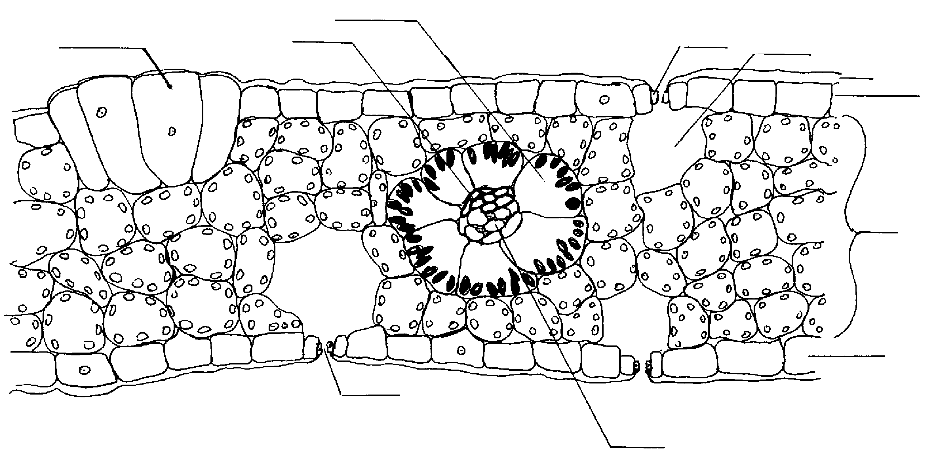
Figure 7-4. Monocot Leaf Cross-Section.

External Microanatomy of Leaves
Make a transparent acetate impression of a leaf surface by the procedure described below. Collaborate with others so that you have results from both the upper and lower surface of both a dicot and a monocot. Compare appearance of the surfaces: veins, epidermal cells, stomate numbers and trichomes (hairs).
Procedure:
- Be sure to use the plants expressly provided for this exercise because the procedure is somewhat destructive.
- Put a few drops of acetone on a fragment of cellulose acetate, quickly spread the acetone evenly over the surface, and allow it to evaporate.
- As soon as the liquid starts to turn filmy (15 to 60 seconds, depending on how much was initially applied), apply the softened cellulose acetate surface to the leaf surface and firmly but carefully hold in place for 60 seconds.
- Peel the acetate strip from the leaf, sandwich the strip between two microscope slides without using water, and examine under the microscope. Close the diaphragm to deepen focus, and, if necessary, adjust the light coming from the sub stage lamp to see maximum detail.
- Figure out what stomates look like, count the number which appear in your 400X microscope field, and fill out the table at Q1 on the answer sheet, combining your observations and those of other students working with different surfaces.

Internal Anatomy of Leaves

Dicot, Monocot and Conifer Leaf Comparison
Collaborate with students in your vicinity by setting up THREE compound microscopes, one with a lilac (Syringa) leaf slide, a second with a corn (Zea) leaf, and the third with a pine (Pinus) leaf. Compare the slides at the same magnification and fill in the table at Q2 on the answer sheet. The objective is to take a close, comparative look at all three kinds of leaves, and consider the biological implications of their differences. In some cases, the answers you enter in the table will depend on the slides you look at and vary from group to group. Label Figures 7-3, 7-4, and 7-5 with the structures that are emphasized in the explanation that follows the figures.

Interpretation
The three types of leaves you are comparing come from quite unrelated plant species, which also happen to differ in their environmental tolerances. Lilac leaves are considered to be “normal” mesophytic [adapted to average conditions- not too wet nor too dry] dicotyledon leaves: a good example to learn for "typical" leaf structure. Corn, like many grasses of tropical origin, is especially well adapted to rapid growth in warm, bright conditions. A pine leaf, finally, is xerophytic [considered to be highly adapted to resist both drying and freezing]. Unlike the lilac and corn leaves, it will stay on the tree for as many as seven consecutive growing seasons, and survive the intervening winter(s) unimpaired.
Lilac leaves are broad and thin and intercept light efficiently. Their extensive surface makes them vulnerable to excess water loss. The loss is much reduced, however, by an epidermis of closely packed cells covered with a transparent waxy cuticle.
The thick pine leaf is less vulnerable to water loss because it has a much smaller evaporative surface, sunken stomates, a thick cuticle, sclerified epidermal cells, special arrangement of the photosynthetic tissues and an endodermis that can control water movement within the leaf. These extreme water conserving features are especially important during the winter, when frozen xylem prevents water replacement [sometimes for months at a time]. Underlying and reinforcing the epidermis of pine leaves are one to three layers of sclerified hypodermis. The combination of these extra layers and a well developed cuticle result in pine leaves having better control of water loss than lilac leaves.
The corn leaf is intermediate in ability to absorb light and intermediate in its ability to resist drying out. It survives frost no better than a lilac. A distinctive feature of upper epidermis of a corn leaf are rows of large, bulliform cells that run full length of the leaf lamina. Under extended drought conditions, the bulliform cells collapse and cause the leaf to roll up. In doing so, a high percent of the stomates are covered by other parts of the lamina or are inside of the cylinder formed by the leaf. As a result, the leaf loses much less water through transpiration and the plant may survive the drought period. Of course, the same features that reduce water loss also reduce CO₂ absorption and photosynthetic rates are reduced.
The photosynthetic mesophyll tissue occurs just inside the epidermis, often in several layers. Note that in the lilac leaf the cells of the mesophyll are packed densely in the upper part of the leaf, and loosely in the lower part. This is consistent with a leaf that is positioned horizontally to the ground, with predictable upper and lower surfaces. The close packing and orderly arrangement of the upper palisade mesophyll enhance light interception, perhaps at the expense of efficient diffusion of carbon dioxide. The more loosely arranged spongy mesophyll beneath favors carbon dioxide diffusion. Most of the stomates in the lilac leaf occur in the lower epidermis and provide passages between the outside air and the spongy mesophyll.
Note that corn leaves lack mesophyll differentiation. This is in keeping with the less horizontal orientation we expect in a grass leaf. Sun is likely to strike the relatively vertical corn leaf from either side, depending on the time of day. Look for stomates in the corn leaf cross section. Just to the inside of the leaf beneath each stomate is a sub-stomatal chamber, which serves to improve the diffusion of carbon dioxide through the mesophyll.
In lilac and corn leaves, the mesophyll occupies all the space between the upper and lower epidermis except for the vascular bundles (veins) that traverse the leaf. In pine leaves, though, the mesophyll extends only to the endodermis, which separates it from the central transfusion tissue, in which the vascular bundles are embedded. Pine mesophyll cell packing is not easily inferred from a cross section. Your slide may show densely packed mesophyll between the epidermal layers and the endodermis as shown in Figure 7-5, but it may show instead many air spaces and few cells. The difference from one cross section to another results from bands of closely and loosely packed cells alternating along the length of the leaf. Look for this variable distribution in the longitudinal pine needle section displayed on the demonstration bench. The pine mesophyll cells themselves have distinctive lobing and are likely to stain darkly because of high resin content in a prepared slide. Such resin concentrations probably help increase freezing resistance. A last distinctive feature of the pine leaf mesophyll is the presence of resin canals essentially identical to those found in the wood and bark.
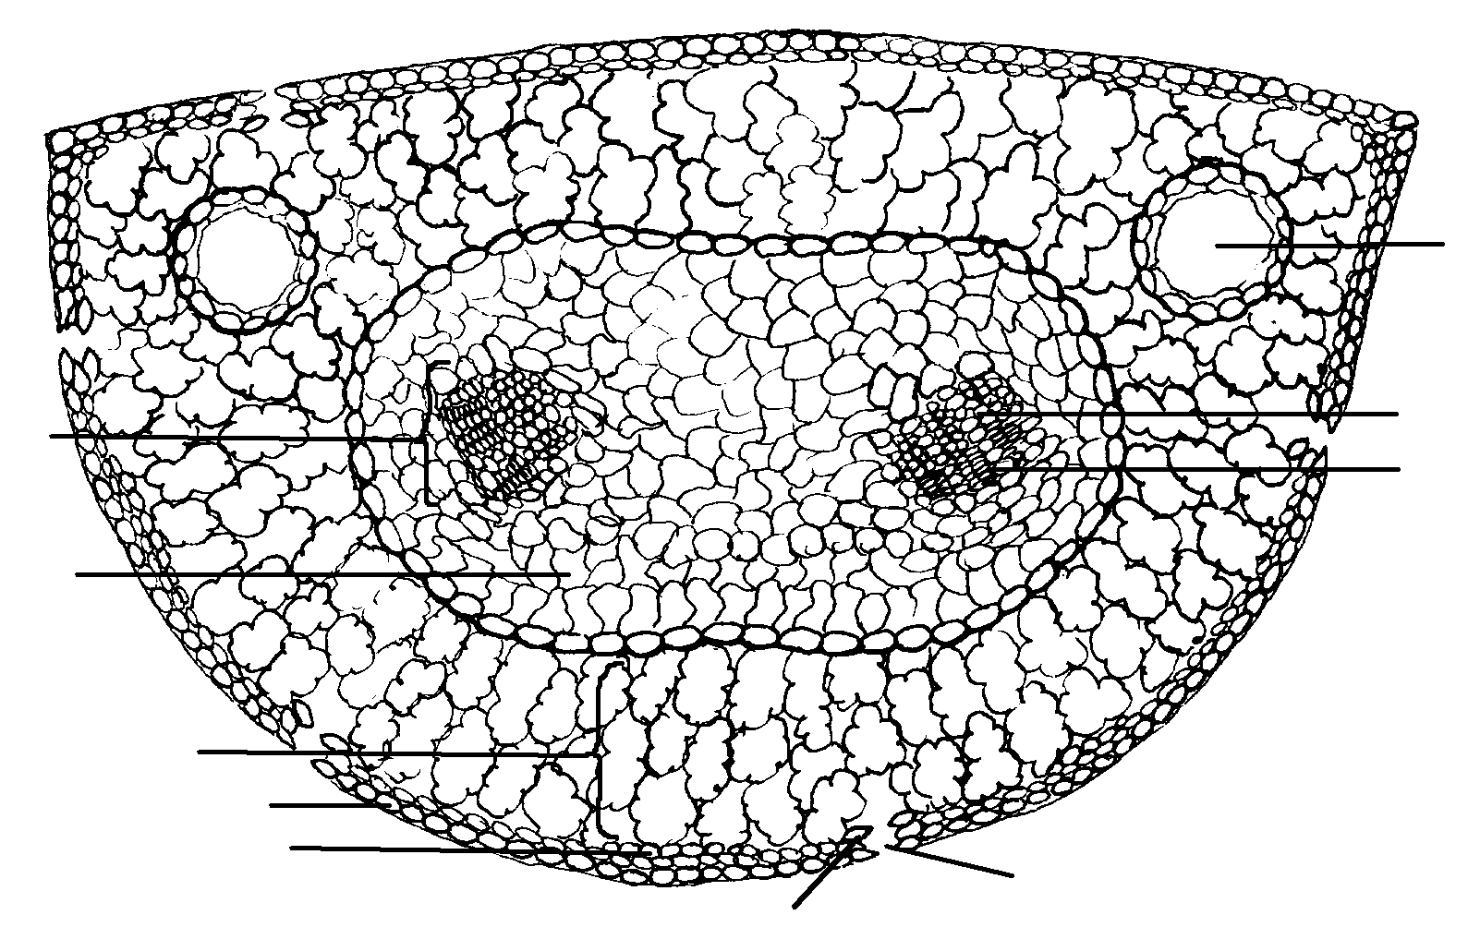
Figure 7-5. Pine (Pinus) Leaf Cross Section.
In lilac and corn leaves, vascular bundles range from very large, like the midrib, to a cylinder of just a few cells near the end of a small vein. Look for that variation in your slides. In lilacs, a cylinder of thick-walled cells, the bundle sheath, surrounds all vascular bundles except the largest and smallest. The bundle sheath adds strength to the lilac leaf, but not enough to completely support it. Most of the rigid flatness of the leaf comes from the normal water pressure (turgidity) of the thin-walled parenchyma of the mesophyll. This becomes obvious during dry times when the leaves wilt. Good sized lilac vascular bundles may be further anchored in place by bundle sheath extensions, which extend to the epidermis. Bundle sheath extensions also anchor large veins in corn leaves. Between the parallel veins of a monocot leaf are perpendicular small cross veins called commissural veins. Several smaller parallel veins typically occur between pairs of main veins. In many grasses, including the corn you are observing, these smaller vascular bundles have a cellular arrangement called Kranz (German for “wreath”) anatomy. Kranz anatomy has evolved independently in many monocots and some dicots and allows C₄ photosynthesis, an especially efficient kind of photosynthesis covered later in the course. The special bundle sheath of small corn veins contrasts with that of lilac, a plant that undergoes normal C3 photosynthesis.
Overall, a pine needle has a greater proportion of thick-walled cells than a lilac leaf or corn leaf, and is less likely to show conspicuous wilting even if it loses a lot of water. In lilac and corn leaves, the stomates, with their paired guard cells, are right on the surface. In pines, each stomate is recessed into the leaf surface, producing what are referred to as sunken stomates. Sunken stomates tend to reduce water loss, because each water vapor molecule must follow a longer path to escape the leaf. The price paid is in slower carbon dioxide uptake, also because of the longer diffusion path.

Variation in Leaf Development in Response to Environment

Aquatic/Terrestrial
Plants that grow in water [hydrophytic plants] are faced with special requirements for efficient functioning. We have seen that the leaf of a land plant is typically specialized for light interception, carbon dioxide uptake, and insofar as possible, water retention. A leaf usually has little mineral absorption function, because air is a far less reliable source of minerals than the soil.
An aquatic plant, in contrast, absorbs most of its minerals, as well as its carbon dioxide, through its stems and leaves. Aquatic plants leaves are the principal organs of photosynthesis but, of course, they don’t need modifications for transporting or retaining water. They tend to have little or no cuticle and greatly reduced amounts of xylem.
Observe on display the contrast in leaf development in plants that start their growth under water and complete it in the atmosphere. The much-divided leaves represent a modification that facilitates mineral and carbon dioxide uptake, though at the expense of the abilities to absorb light and to remain flat. The leaves, or in some cases even the parts of leaves that develop in the air, have an anatomy much more typical of the “typical” leaves covered previously. Production of two (or more) distinct structural leaf types is called heterophylly. See the demonstration slides of floating leaves of water lily and submerged leaves of Potomogeton. Especially note the cuticle development and amount of air space within each leaf.
Answer question Q3 on the answer sheet.

Sun-Shade Leaves—Internal Anatomy
The differences between a sun leaf and a shade leaf are internal as well as external. Observe on demonstration the differences in mesophyll development, cuticle thickness, stomate density, and vein distribution between a sun leaf and a shade leaf of the same species. What major cash crop is grown in shade to produce large thin leaves?

Sun/Shade (Demonstration)
Less extreme variation in leaf anatomy is quite common in normal terrestrial plants that are tall enough to be self-shading. On display are leaves taken from the shaded lower branches and from the unshaded upper branches of Hill's oak. Answer question Q4 on the answer sheet.

Modified Leaves
Virtually any terrestrial species has leaves that are more or less specialized for water retention against the evaporative demands of a dry atmosphere. (A variety of more extreme drought adaptations of plants will be on display in a later lab.) Many plants, however, have leaves specialized for more unusual functions. Observe the specialized leaves on display in today's lab:

Tendrils
Tendrils are thread-like modifications of stems, leaves, or leaflets that help attach a plant to another object. Both agricultural and weedy species in the pea and grape families are likely to have leaves or leaflets modified as tendrils. The value of tendrils to a forest vine is obvious in enabling the plant to grow up to a better light environment. Answer question Q5 on the answer sheet.

Spines, Thorns, and Prickles
Spines are, technically speaking, modified leaves, but few of us are likely to be too concerned about the origin of the plant part that is causing us pain. Real spines that have a leaf origin include those of cacti, currents, and gooseberries. Similar structures of different origin include the thorns of hawthorns (modified stems), and the prickles of blackberries and raspberries (stem epidermis extension). Answer Q6 on the answer sheet.

Leaves as Agents of Reproduction
Some plants have notably succulent leaves (thick, water-filled). Typically, such leaves have the capacity to form adventitious roots if they fall to the ground and eventually grow into whole new plants. A still more extreme modification found in some species of the genus Kalanchoe is the direct production of plantlets on the tips or edges of the leaves. Leaves that act as reproductive agents are almost always thick enough to store water. Answer Q7 and Q8 on the answer sheet.

Colored Leaves.
Tropical forest-edge communities often include ground layer plants with brightly colored or patterned leaves; for example, Coleus and Croton species. Since the brightest part of the leaf is often an area without chlorophyll, it is intriguing to speculate about why such plants have evolved leaves that actually have less photosynthetic surface. Answer Q9 on the answer sheet.

Water Shedding Leaves.
Species native to climates where rainfall is very great are likely to have leaves which have entire, unlobed edges, and which terminate in an extended "drip tip." Such a leaf sheds water efficiently, which may reduce the weight of water borne by the plant during a torrential downpour. Effective water shedding may also keep the stomates from being blocked, so carbon dioxide uptake remains good. Answer Q10 on the answer sheet.

Water and Mineral Trapping Leaves.
Species that grow in environments where water or minerals are difficult to obtain may have leaves that are arranged to trap water instead of shedding it, and to catch airborne debris. Examples include pineapples, which are native to dry habitats, epiphytes (plants which grow on other plants), whose roots are aerial and do not reach the soil, and plants of semi-arid environments, like yuccas, agaves, and aloes. In the mineral deficient bogs of northern Wisconsin are found even more extreme modifications for mineral capture: the leaves of insect trapping pitcher plants and sundews. The Venus flytrap, present and even locally abundant on mineral deficient sandy soils in the Carolina coastal plain, has the most spectacular leaf modification of all for supplementing its mineral supply. Answer Q11 on the answer sheet.

Storage Leaves.
Food storage is typically associated with fleshy roots and stems, but leaves can be modified for food storage, too. Plants like lilies and onions store food in bulbs. A bulb consists mostly of thickened leaf sheathes, but is also likely to include some stem tissue at the base or in the center. Complete Q12 on the answer sheet.

Poisonous Leaves.

A non-anatomical leaf modification is the production of substances that are poisonous to grazers or even to other plants. Leaves that are highly toxic to man include those of dogbane (internal) and poison ivy and poison sumac (external). Wisconsin species whose leaves are known or suspected to contain substances toxic to other plants include black walnut trees, orange hawkweed, and bracken fern. What kind of visual evidence would indicate the production of allelopathic (plant killing) substances by a plant in nature?

Some Specialized Leaf Terminology
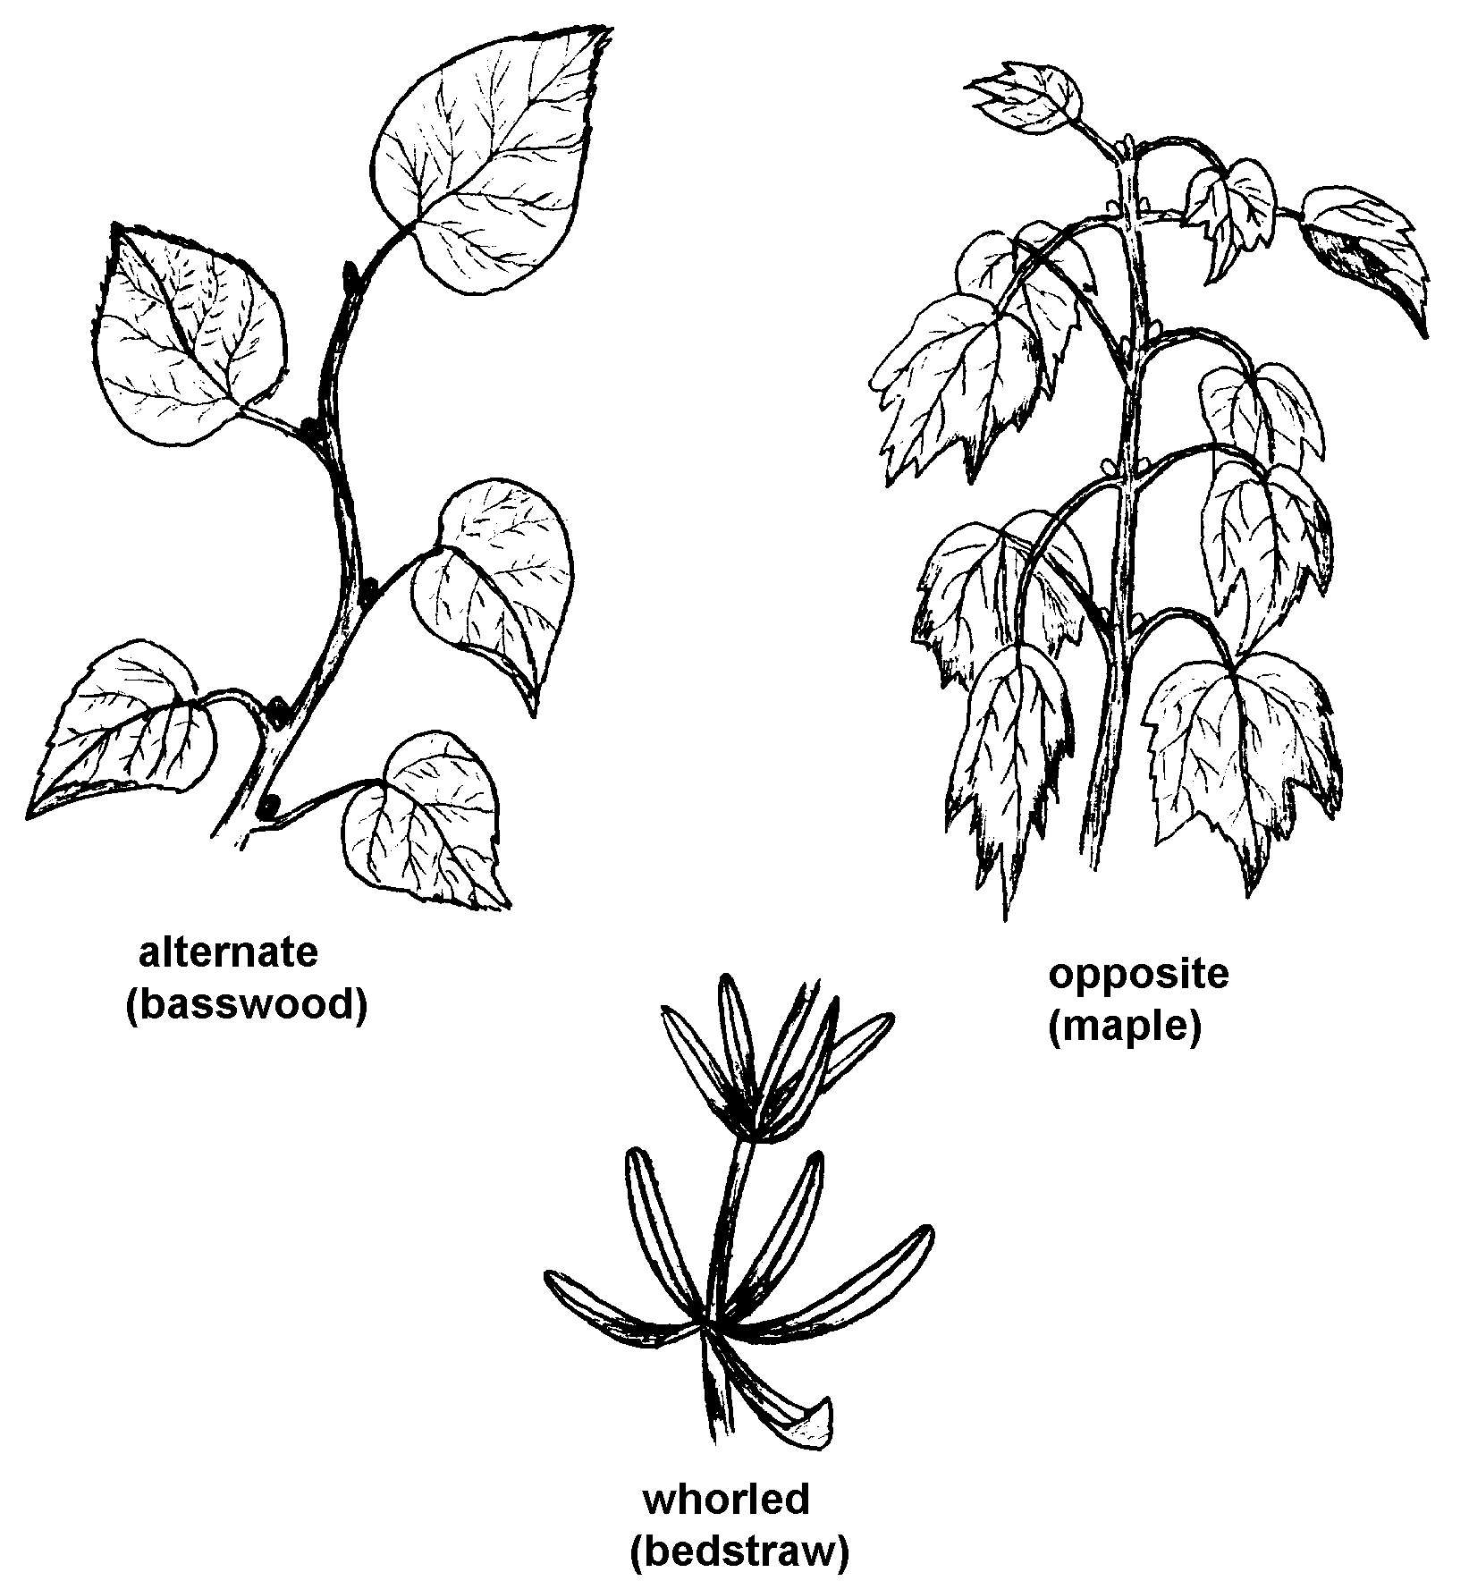
Figure 7-6. Leaf Arrangement.

Arrangement
Alternate: attached singly (attached on alternating sides along the twig).
Opposite: attached to the twig in opposing pairs.
Whorled: attached in clusters of three or more.

Compounding
Simple, if leaf consists of a single blade (remember from your study of twig anatomy, that there is always an axillary bud where a true leaf joins the stem).
Compound, if leaf consists of two or more blades (leaflets) attached to a central axis without axillary buds, the whole compound leaf attached to the twig with an axillary bud present.
Note: If the leaflets are further divided into smaller blades, the leaf is twice compound.

Venation
Net, if veins branch and re-branch into an elaborate network (dicotyledons).
Parallel, if all visible veins run side by side for the length of the leaf (monocotyledons).
Net-veined leaves tend to be broad; parallel veined leaves tend to be long and narrow but there are plenty of exceptions.

Overall Shape of Blades
Linear--very long and narrow.
Lanceolate--shaped like a spear point: quite narrow, but broadest towards the base and tapering towards the tip.
Oblanceolate--as above, but widest beyond the middle so that the gradual taper is towards the leaf stalk (petiole).
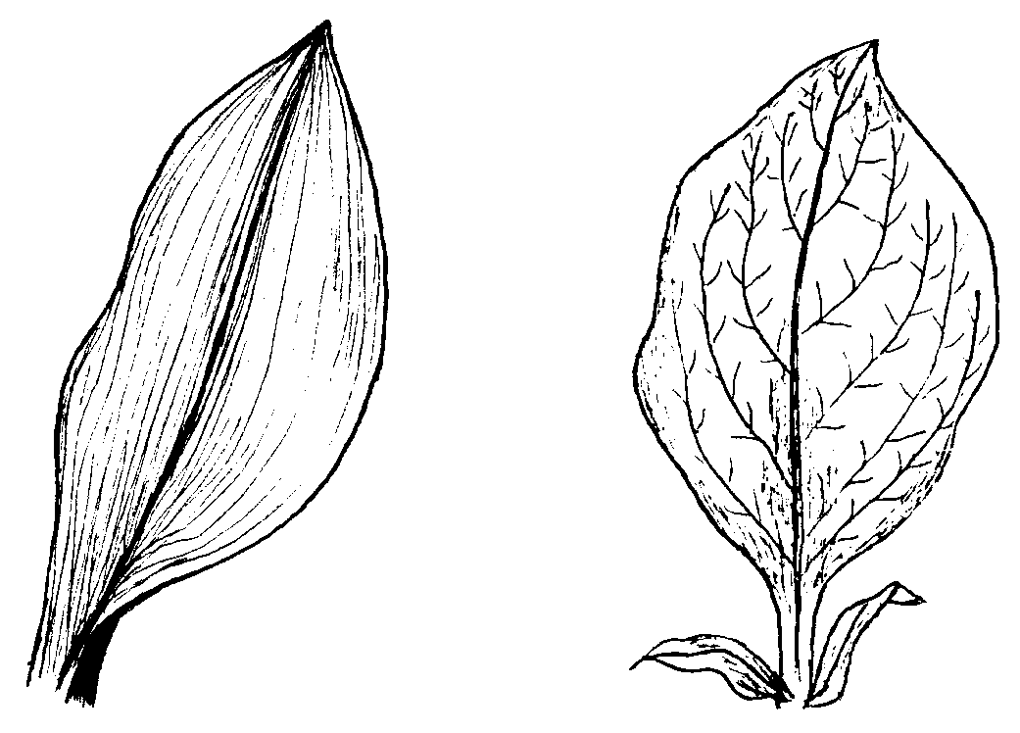
Figure 7-7. Leaf Vein Pattern.
Ovate--egg shaped, but usually tapered towards the tip; broadest below the middle.
Obovate--as above, but widest beyond the middle.
Note: Many other descriptive terms are used to describe leaf shape; some obvious, like "triangular," and some not so obvious, like "cordate," which means heart-shaped, and "peltate," which means circular.

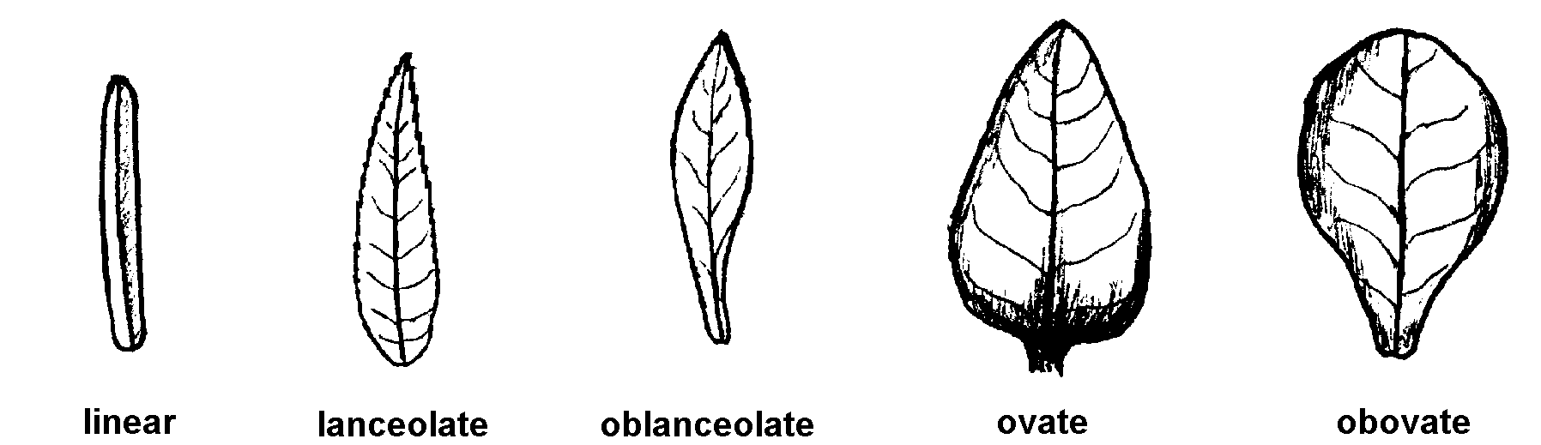
Figure 7-8. Leaf Shape.

Lobes
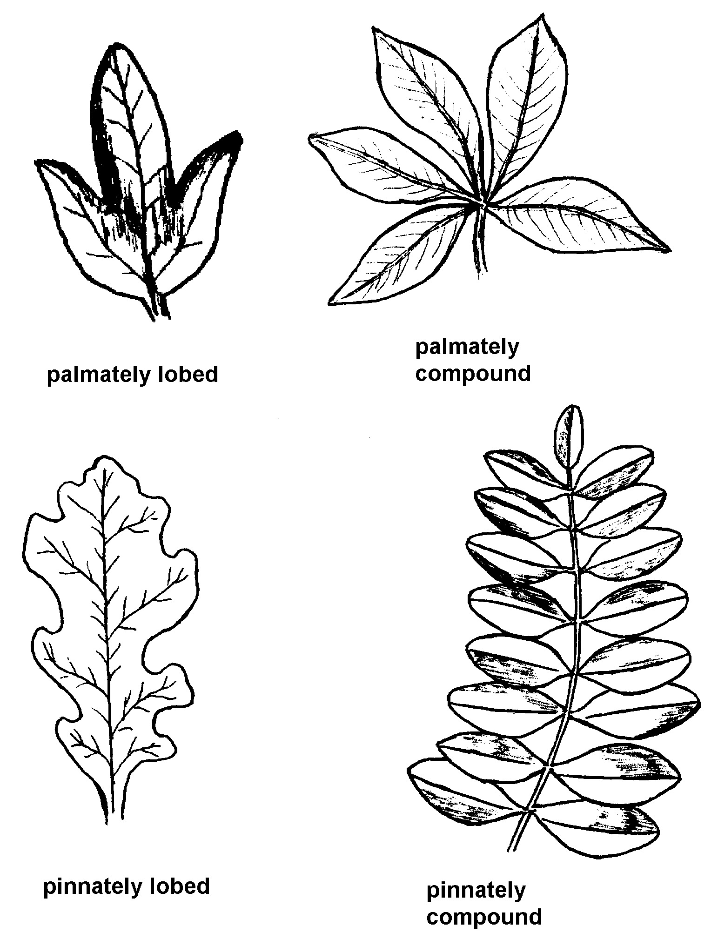
Figure 7-9. Lobed and Compound Leaves.
Both lobing and compounding can be either:
Palmate, if the lobes or leaflets converge on a single point, like the fingers to the palm of a hand, or
Pinnate, if the lobes or leaflets converge on different points along the midrib or main leaf axis.

Serration
Entire leaves have no teeth.
Single toothed leaves have an evenly toothed margin.
Double toothed leaves have small teeth within larger teeth.
Toothed leaves are the norm in Wisconsin woody plants, but rare in the tropics.
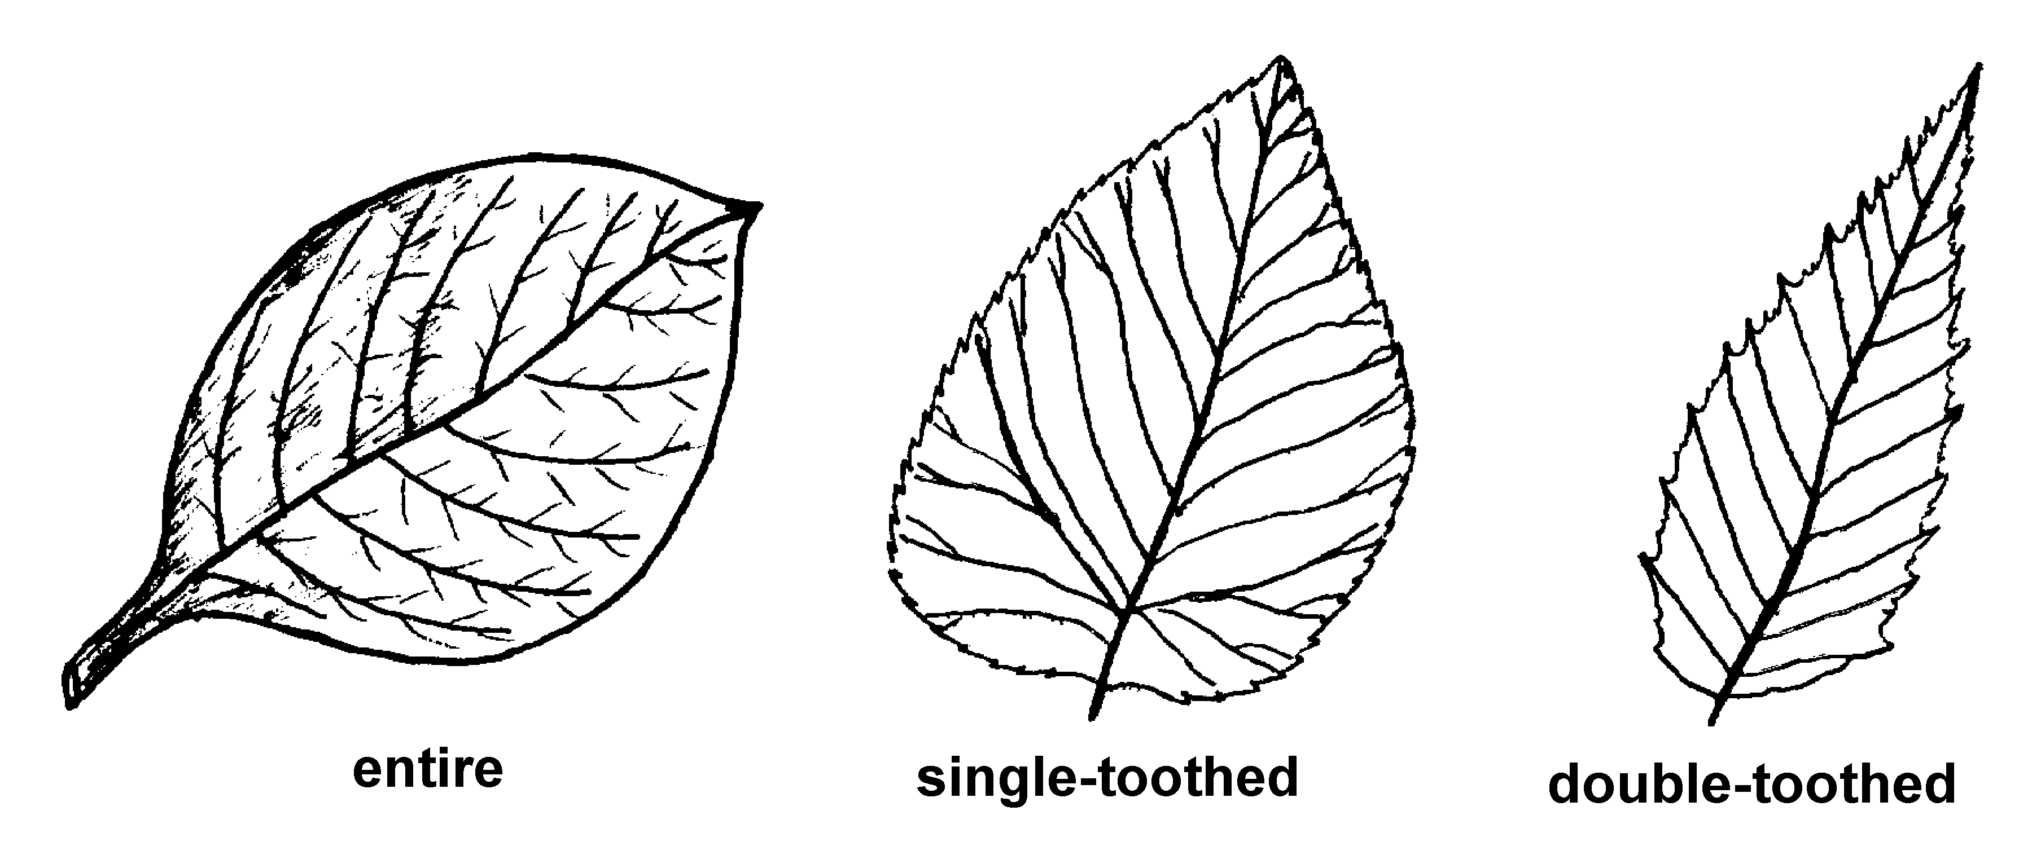
Figure 7-10. Leaf Teeth.

Surface Texture
Glabrous leaves have no hairs.
Hairy leaves are described by almost countless numbers of terms, depending on the abundance, density, and texture of the hairs. Gleason and Cronquist: Manual of Vascular Plants of Northeastern United States and Canada, for instance, lists 33 different terms designating surface hairiness variations!
Glaucous leaves are hairless, but have a gray or blue-green color from surface material that can be easily wiped off.
Glands can also contribute to surface texture, often simply by secreting substances that are sticky to the touch. The glands themselves may be directly visible or detectable only with a hand lens.

Size
The usefulness of leaf size in plant identification is reduced because of the dependence of size on growing conditions. Size is useful, though, where expected differences are great, or where there are few other obvious distinctions.

Exercise
Use the leaf key provided in lab to identify some of the greenhouse species on the lab tables.
KEY WORDS

vegetative
carbon dioxide
stomate
blade
petiole
stipule
vein
midrib
leaflet
sessile
sheath
epidermis
cuticle
hypodermis
bulliform cell
mesophyll
palisade mesophyll
spongy mesophyll
vascular bundle
endodermis
transfusion tissue
bundle sheath
turgidity
bundle sheath extension
Kranz anatomy
sunken stomate
sun leaf
shade leaf
tendril
spine
thorn
prickle
succulent leaf
epiphyte
bulb
allelopathic
simple
compound
net-veined
parallel veined
linear
lanceolate
oblanceolate
ovate
obovate
palmate
pinnate
entire
single toothed
double toothed
glabrous
glaucous
gland
mesophytic
xerophytic
hydrophytic
heterophylly

Answer Sheet, Laboratory 7
Q1 Table 7-1. Leaf Surface Characteristics.
 | Surface | Trichomes (Hairs)  many / few / none | Stomates  many / few / none
Bean Leaf | Upper
 | Lower
Corn Leaf | Upper
 | Lower
Note: Stomate density and other leaf surface characteristics vary from place to place on the leaf and from leaf to leaf on a plant. Typical stomate counts from a variety of plants are posted in lab.
Q2 [See reverse]
Q3 What sorts of anatomical contrasts would you expect between the upper and lower surfaces of a floating leaf plant like water lily?
Q4 If you wanted to experimentally stimulate an oak sapling to produce leaves with large thin blades and small sinuses (open spaces between lobes), how should you modify its growing conditions?
Q5 Could tendrils have similar value to meadow or pasture species?
(over)
Q1. Table 7-2. Leaf Comparison.
 | Lilac (Syringa) | Corn (Zea) | Pine (Pinus)
Thickness Rank
(Thickest to Thinnest)
Cross Sectional Shape (Describe or Sketch)

Number of Epidermis-Like Layers
(Epidermis + Hypodermis)
Strong Difference between Upper and Lower Halves of Leaf (Y/N)?
Shape of Mesophyll Cells (Sketch)

Number of Vascular Bundles Intercepted, Whole Leaf Width (Scan and Count)
Stomates Sunken Below Surface
(Y/N)?
Bulliform Cells Present (Y/N)?

Number of Resin Canals Shown in Cross Section
Cuticle Detectable (Y/N)?
[usually stains pink]

Q6 Think about where you personally have encountered spiny plants: Swamps? Pastures? Thickets? Deep shade under hardwoods?
Q7 In what sort of climates would you expect plants to notably benefit from this sort of reproduction?
Q8 Is this reproduction sexual or asexual?
Q9 What competitive advantage would be gained by a plant that has colored leaves?
Q10 What effect might efficient water shedding have on a leaf's resistance to pathogenic organisms like fungi and bacteria?
Q11 Insect trapping plants can’t grow in the dark any better than other plants can even when they trap lots of insects. What does this tell you about what they actually get from the animals they trap?
Q12 Can you think of any bulb-forming plants besides the examples above? List one or more:

